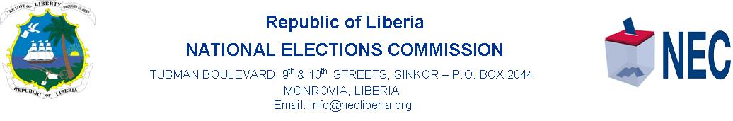
PRESS STATEMENT
MONROVIA, 24 June 2022, Friday, on 22 June 2022, the Chairperson of the National Elections Commission (NEC), Madam Davidetta Browne Lansanah welcomed the new Chief of Party for Elections and Democracy Activity for the USAID funded group, Democracy International (DI) in Liberia, Ms. Stephanie Lynn on an acquaintance visit to the NEC.
Ms. Lynn comes to the job with three decades of professional experience in more than 20 nations building leaders in elections, civil society development and democracy support to underrepresented groups, including women among others. she has worked in Africa, Eastern Europe and Asia.
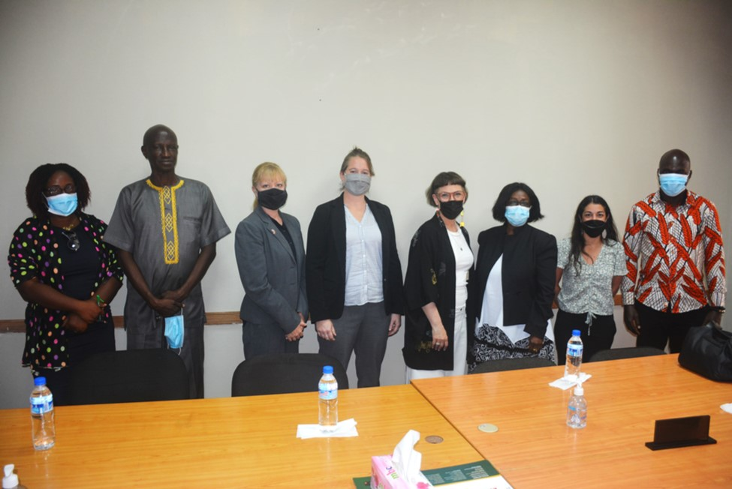
Mr. Lynn replaces the previous Chief of Party, of DI, Mr. Xav C. Flowers who ended his tour of duty recently.
The 4-member DI delegation, 2-member USIAD team, NEC Boss and Commissioner Dukuly after the meeting.

Democracy International, DI and the National Elections Commission, NEC are partnering in several support activities including Research on Political Economy and Analysis, and Budget adaptation, Essay contest for NEC Poll Workers and strengthening of NEC leadership for smooth operation of NEC to deliver on its democratic gains.
Ms. Stephanie Lynn was accompanied by a 4-member delegation including Ms. Naomi Rasmussen, who is the Director of Program Management for Democracy International and oversees DI’s analytical and implementation programs globally.
Other members of the DI delegation were, Mrs. Patmillia Doe Paivey, Director of Programs, and Mr. Moses Clarke, Election Program Officer. Also in the meeting were Suzanna Truchard, Democracy, Rights, and Governance Director and Mary Zell, all of the United States Agency for International Development, USAID.

